How to Install Questar PWA Secure Browser and Supporting Extension on Chromebooks
Use this procedure to install the Questar-NY-PWA Secure Browser and its supporting Chrome extension for a Chromebook organizational unit.

📘 Installation instructions
- In the Google Admin console, go to Devices → Chrome → Apps & Extensions → Kiosks.
Select the organizational unit where the PWA will be installed, select the + button, and choose Add by URL.
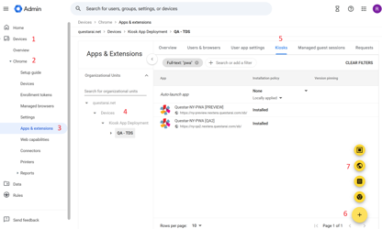
- In the Add by URL window, enter the following URL and select Save:
https://ny.nextera.questarai.com/sb
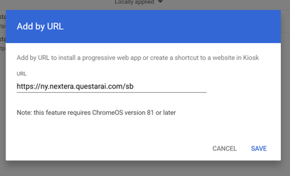
- Select Agree to grant the permissions required by the PWA.
- After the PWA is added, select Add Extension → Add from a custom URL.
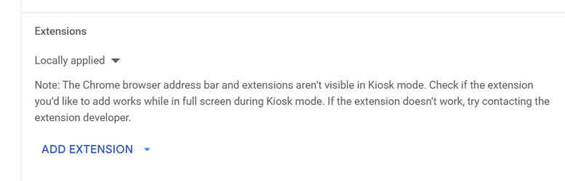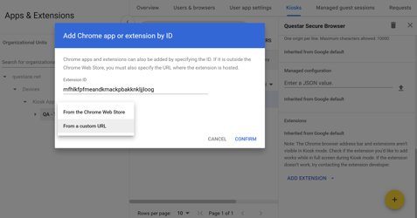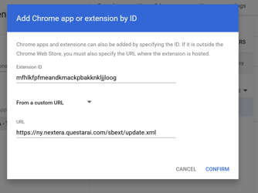
- In the Add Chrome app or extension by ID window, open the drop-down menu and select From a custom URL.
- Enter the following information, then select Confirm:
  - Extension ID: mfhlkfpfmeandkmackpbakknkljjloog
  - URL: https://ny.nextera.questarai.com/sbext/update.xml
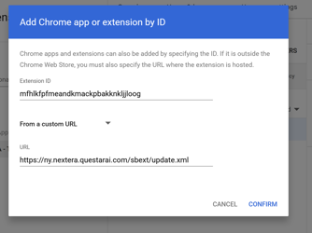
- After the extension is added, select Save (upper right corner).
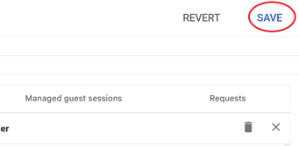
After the configuration is complete, verify that Questar Secure Browser appears in the Chromebook kiosk apps list.
Note: Before saving, ensure nothing is toggled ON.
Note: The name of the app will change to Questar-NY-PWA after first load.

📋 Verification checklist
- The PWA URL was added to the correct organizational unit.
- Required PWA permissions were accepted.
- The supporting extension was added from the custom update URL.
- Questar-NY-PWA (or Questar Secure Browser) appears in the kiosk apps list.

